From: https://www.dailymail.co.uk/sciencetech/article-3019307/Could-mushrooms-save-human-race-Network-fungus-help-fight-climate-change-pandemics-experts-claim.html

Could mushrooms save the human race? Network of fungus could help fight climate change and pandemics, experts claim
- Team of experts are making a film about the wonders of mycelium
- It's a vast underground network of fungus that holds soil together

- Scientists claim it could absorb carbon dioxide to slow climate change

- Fungus could also create new drugs and pesticides to boost health

By SARAH GRIFFITHS FOR MAILONLINE
PUBLISHED: 06:19 EDT, 31 March 2015 | UPDATED: 07:52 EDT, 31 March 2015

Cutting edge technology such as super efficient solar panels and nanorobots are being developed to fight climate change and disease.
But a team of experts believe that the humble mushroom is just as effective in helping humans continue to survive and thrive on Earth.
They claim that mycelium – a vast underground network of fungus – could save the world by absorbing carbon dioxide and producing more antibiotics, among other benefits.
Scroll down for videos
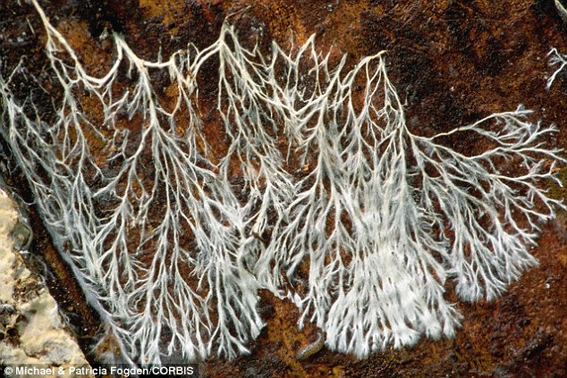
+4

Experts claim that mycelium – a vast underground network of fungus – could save the world by absorbing carbon dioxide and producing more antibiotics. This image shows fungus mycelium growing on a tree
Mycelium is found all over the world and holds soil together. It's the part of the mushroom that we don;t usually see and makes nutrients, breaks up pollutants, filters water and treats disease.
Soon the potential of this network will feature in a film called Fantastic Fungi, which has just reached its fundraising goal on Kickstarter.
‘An all-star team of artists, scientists, doctors and explorers are joining forces to create a life-affirming, mind-bending film about the mushroom and its mysterious root-like structure: mycelium. What they reveal will blow your mind and possibly save the planet,’ the website says.
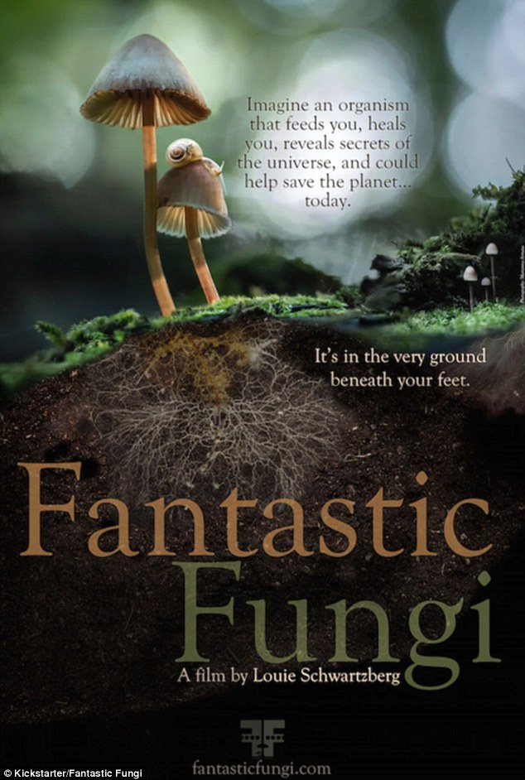
+4

A film about mycelium will 'create a life-affirming, mind-bending film about the mushroom and its mysterious root-like structure: mycelium. What they reveal will blow your mind and possibly save the planet,’according to the group which have just funded their project (a poster is shown above) on Kickstarter
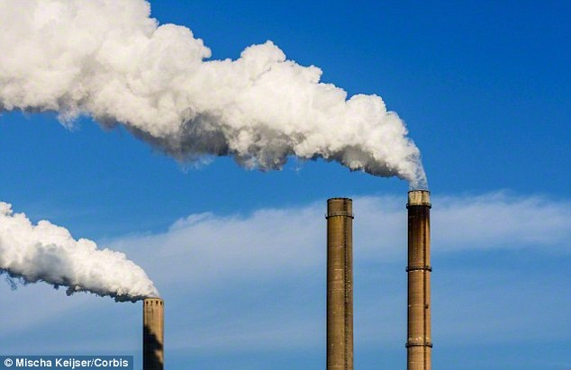
+4

Dr Stamets claims that by growing more mycelium, climate change could be brought under control, because the organism can absorb vast amounts of carbon dioxide. A stock image of smoke stacks is shown

MARVELOUS MYCELIUM
Mycelium is a vast underground network of fungus, which holds soil together.
It can hold up to 30,000 times its own mass in water and nutrients etc.
The largest organism on the planet is a 2,000-year-old fungal mat that stretches over 2,000 acres.
‘Funguses are ‘the grand molecular disassemblers of nature - the soil magicians. They generate the humus soils across the landmasses of Earth,’ Paul Stamets said in a TED talk.
Mycelium produces jewel-like mushrooms that come in countless shapes, sizes and colours, such as pink, yellow and turquoise.
Experts believe that mycelium is the ‘key to the regeneration of our living planet.’
Mycelium can produce antibiotics powerful enough to prevent diseases and pandemics, such as smallpox.
It absorbs a large amount of carbon dioxide, so more mycelium could help control climate change, they said.
It will explore fungi’s ‘proven ability to restore our ecosystem, repair our health, and resurrect our symbiotic relationship to nature’.
Mycologist Paul Sta​mets, who will be the main voice of the film, told Motherboard: ‘Mycelium offers the best solutions for carbon sequestration, for preserving biodiversity, for reducing pollutants, and for offering us many of the medicines that we need today, both human and ecological.’
‘Fungi, I think, hold the greatest potential solutions for overcoming the calamities that we face,’ said the scientist, who has talked on the topic at TED and authored several books about mushrooms.
He refers to mycelium as ‘nature’s internet’ because if part of a fungus is harmed, the rest of the network can respond quickly to disruptions.
For example, if one branch of the thread-like mycelium is broken, the organism finds alternative pathways to carry nutrients and information, much like how packets of data can be transported across the internet.
In his book, 'Mycelium Running', Stamets takes the idea a step further.
He writes: 'I see the mycelium as the Earth's natural Internet, a consciousness with which we might be able to communicate.
'Through cross-species interfacing, we may one day exchange information with these sentient cellular networks.
'Because these externalised neurological nets sense any impression upon them, from footsteps to falling tree branches, they could relay enormous amounts of data regarding the movements of all organisms through the landscape.'
The complex chemistry of mycelium has been shown to produce antibiotics powerful enough to prevent many diseases and stop pandemics.
Scientists even believe that it could help to deal with scenarios such as such as terrorists starting outbreaks of smallpox, for example.
In a 2008 TED talk, Stamets said that three strains of Agarikon mushrooms, for example, have been shown to be ‘highly active’ against flu viruses.
The film will talk about research which shows mycelium as a viable alternative to pharmaceuticals to treat breast cancer, Alzheimer’s disease and post-traumatic stress syndrome.
https://www.youtube.com/watch?time_continue=1&v=XI5frPV58tY
In a 2008 TED talk (above), Stamets said that three strains of Agarikon mushrooms, for example, have been shown to be ‘highly active’ against flu viruses
It will then reveal how the spongy network could be used to clean up toxic oil spills, fix the collapse of bee colonies and other environmental disasters such as polluted rivers, by filtering bacteria like E.coli out of water to clean soil, for example.
In 1996, Stamets began work to explore how mushrooms can clean up oil spills and found that oyster mushrooms combined with wood chips can be spread onto soil contaminated with oil, to clean it up within one month.
Nine weeks after the 'disaster', the dish of soil was home to seedlings and plants.
He came up with the idea of a 'mycoboom' to clean waterborne oil spills. A tube filled with oyster mushrooms could be used to break down petroleum in a contained area and a similar technique was found to 'eat' nerve gas too.
Stamets believes that mushrooms could also be used to clean floodwaters, which can be a haven for potentially fatal bacteria.
They could also be used to filter out endocrine disrupters and pharmaceutical residues, for example, which disrupt ecosystems and can damage human health.
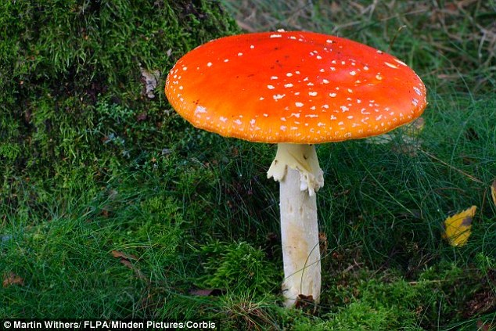
+4

‘Fungi, I think, hold the greatest potential solutions for overcoming the calamities that we face,’ said Stamets, who has talked on the topic at TED and authored several books about mushrooms. A stock image of the attractive Fly Agaric mushroom is shown
Stamets has also already shown that fungus can act as pesticide and could revamp the industry by using nature to keep insect pests at bay.
He even claims that by growing more mycelium, climate change could be brought under control, because the organism can absorb vast quantities of carbon dioxide.
The gas is responsible for 60 per cent of the 'enhanced greenhouse effect,' and the dominant cause of global warming is fossil fuels burned by humans.
The Intergovernmental Panel on Climate Change (IPCC) has set targets to cut emissions by 80 per cent in the UK by 2050 below 1990 levels.
The long-term aim is to stop the global temperature rising by more than 2°C by the end of the century.
To meet this goal, which 160 governments have promised to meet, will require zero emissions and possibly the removal of carbon dioxide, which could mean more mushrooms may play a part.
The experts say that more mycelium could be produced easily and quickly by encouraging people to grow mushrooms, which spread mycelium and stop burning forests and removing dead wood, which robs mycelium of nutrients.
Another ambitious use of mycelium could be space travel, Discover Magazinereported. This is because the network is adept at creating soil and can tolerate and even thrive on radiation, meaning it could be used on missions to colonise other worlds.

Read more:
- How Mushrooms Could Hold the Key to Our Long-Term Survival as a Species | Motherboard
- Fantastic Fungi - a film by Louie Schwartzberg by Fantastic Fungi &mdash; Kickstarter
- How Mushrooms Can Save the World | DiscoverMagazine.com

